### Design Documentation

Jake Southward : w15024065 Computer Science with Web

1. Prioritised Requirements List
2. Personas

|  |  |
| --- | --- |
| **Persona:** | Young Hospital Patient [1] |
| **Photo:** |  |
| **Fictional Name:** | Mathew Johnson |
| **Job title/ responsibilities:** | Bar staff in a city bar |
| **Demographics:** | 21 years old University Student |
| **Environment:** | He has very good computer skills. Very adaptable to learning how a new application or website works. Has an iPhone and a laptop. Regularly uses Uber, Facebook and Instagram. Usually uses his iPhone to browse websites and shop online. |
| **Tasks and Goals:** | Currently in hospital for a short stay due to appendicitis. Wakes up the day after an operation and is in a lot of pain.  - Alerting staff that he is in a lot of pain and feels nauseous. |

|  |  |
| --- | --- |
| **Persona:** | Young hospital Nurse [2] |
| **Photo:** | woman having blood pressure monitor |
| **Fictional Name:** | Gemma Watson |
| **Job title/ responsibilities:** | Works in a hospital as a Nurse. |
| **Demographics:** | 27 years old Has a boyfriend (Unmarried) Nursing Graduate  2 years’ experience as a nurse |
| **Environment:** | She has good computer skills. Very adaptable to learning how a new things. Has an iPhone and a tablet. Regularly uses Netflix, Facebook and twitter. Uses her tablet to watch Netflix shows. |
| **Tasks and Goals:** | Working in the hospital as a nurse.   - Performing medication rounds  - Personal care for patients  - Patient admissions  - Responding to Call bell system |

|  |  |
| --- | --- |
| **Persona:** | Experienced Hospital Nurse [3] |
| **Photo:** | Image result for 40 year old nurse" |
| **Fictional Name:** | Cecilia Smith |
| **Job title/ responsibilities:** | Works in a hospital as a head Nurse. |
| **Demographics:** | 45 years old Married for 20 years  20 years’ experience as a nurse |
| **Environment:** | Intermediate computer user. Sometimes slow to learn how new apps work. Has an android Phone. Regularly uses Facebook, fitness apps and shops online. Uses her phone to buy new clothes online and track her fitness. |
| **Tasks and Goals:** | Working in the hospital as a head nurse.  - Personal care for patients  - Patient admissions  - Responding to Call bell system  - wound dressings  - iv fluid/antibiotic administration  - observations  - discharge planning |

|  |  |
| --- | --- |
| **Persona:** | Hospital patient [4] |
| **Photo:** | Image result for builder" |
| **Fictional Name:** | Kevin Wright |
| **Job title/ responsibilities:** | Has his own building firm. |
| **Demographics:** | 45 years old Married for 5 years  2 children |
| **Environment:** | Rarely uses a computer. Sometimes slow to learn how new apps work. Has an android Phone. Uses his phone to make calls and email clients. |
| **Tasks and Goals:** | In hospital with a severe leg injury he acquired at work.  - Requesting Pain medication.  - making an enquiry to nurses about when he will be in surgery. |

The use of personas helps outline the goals of users and how it reflects the web application I am developing. Three main persona areas are reviewed; Design, User experience, and Features and Functionality. Each persona will be referred to using the identifying numbers in square brackets e.g. [3].

**Design -** Does the design impress … ?

Young Hospital Patient [1] would likely be impartial to the design but may appreciate clarity of text or colour choices.

**User experience -** Did … understand how to navigate the experience, and see all relevant content ?

Young Hospital Patient [1] should have no problem with the user experience. However Hospital patient [4] may need some time to understand basic functionality, this is a key consideration when developing the application. A video tutorial or information screen when first using the application could combat this issue. Additionally making the application as simple as possible without compromising features is a necessity. Considering easy navigation minimal navigation could be achieved by having one main feature screen for the patients to use.

**Features and functionality -** Did … find the features useful to achieve their goals ?

1. Use Case Diagram
2. Site map

**Landing page** (index.htm)

**User Login** (userlogin.php)

**User Tutorial** (usertutorial.php)

**User Dashboard** (userdashboard.php)

**User Alert Active** (useralert.php)

**User Settings** (usersettings.php)

**Staff Login** (stafflogin.php)

**Staff Dashboard** (staffdashboard.php)

**Staff View Request** (request.php)

**Staff analytics** (staffanalytics.php)

**Admin dashboard** (admindashboard.php)

1. Low fidelity wireframe designs

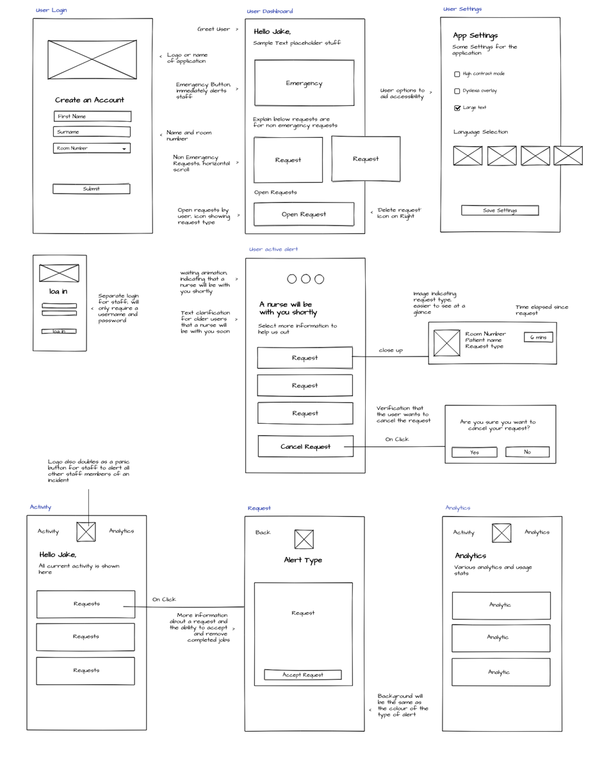

1. Font style

To aid consistency within the web application primarily one font with minimal style variations will be used, this will make the application more cohesive. The primary font chosen is a sans serif, modern and clean font named “Montserrat”. Often boasted on many top 10 lists on the internet as an exceptionally readable font. [1] Font readability is a key consideration for the application as users will be of many demographics, meaning people of all ages primarily the elderly cannot be overlooked during design. For this reason font size will be considered throughout to aid people with low vison and to make links easier to click according to Moore’s law. The only variation from the main font is the logo as it needed to stand out as the (fictional) brand identity. The logo font has a more sophisticated and professional look but is still very readable.

**Calistoga Regular (Logo Font only)**

**Montserrat Bold (Heading and Paragraph text)**

**Montserrat regular (Paragraph text)**

1. Colour scheme

The colour scheme is basic, combining three main colours and several gradients for the interactive elements.

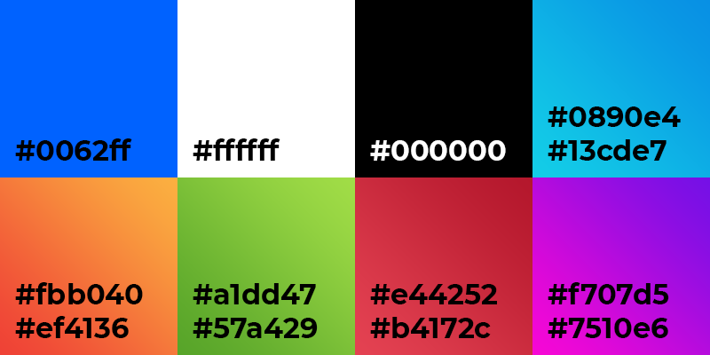

1. High Fidelity wireframe designs

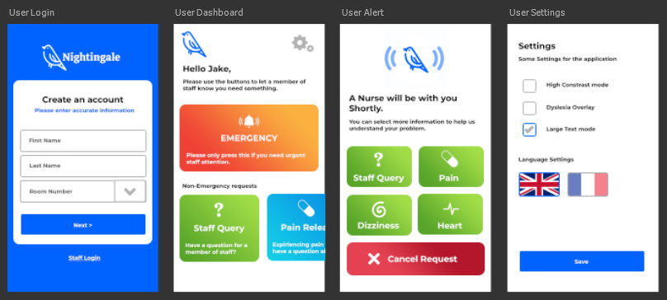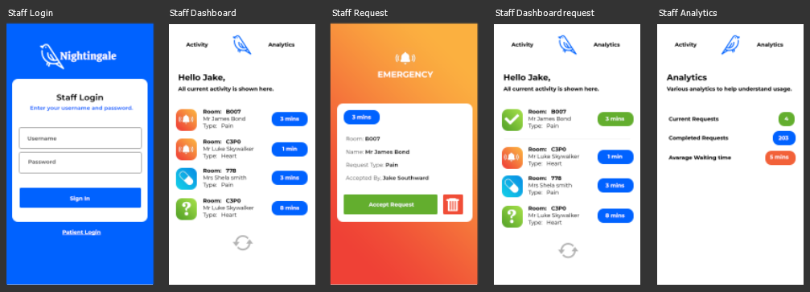

1. Entity relationship Diagram
2. Data Dictionary
3. Bibliography

[1] 10 Best fonts for improving reading experience

https://medium.com/productivity-revolution/10-best-fonts-for-improving-reading-experience-6171ce199e97